SPOTLIGHT
Your Talent. Your Stage.
MINI-PROJECT REPORT
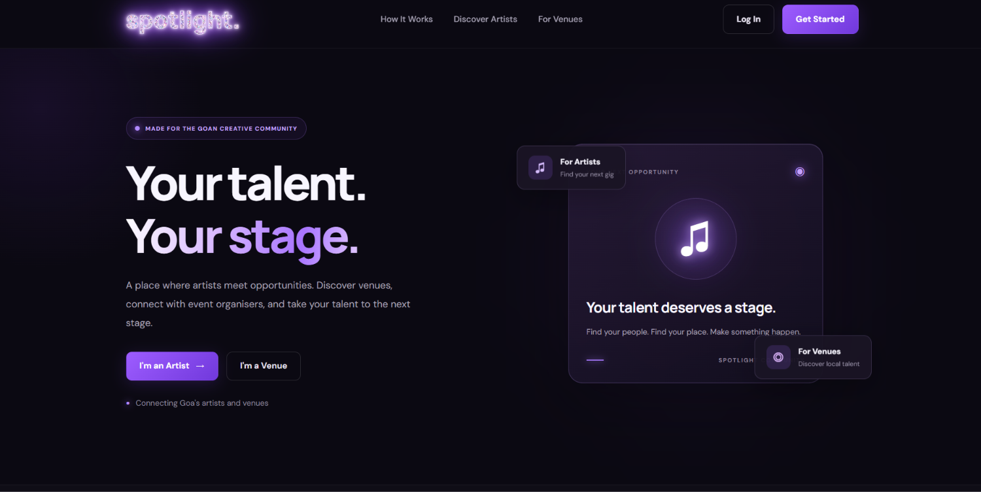
________________________________________________________
Project Team
Kreisler Mozart Goes | Roll No. 2625
Kevin Fernandes | Roll No. 2624
Programme: Master of Computer Applications (MCA)
Object Oriented Technology Lab
Affiliation: Goa University, Goa
Submission date: 29 October 2026
A browser-based platform concept for artist and venue discovery in Goa.

02 Declaration
Student declaration
This report documents the design and implementation of Spotlight, a browser-based mini-project that helps artists and venues/event organisers in Goa present profile information and discover one another. It records the project aim, scope decisions, system design, implementation activities, manually observed tests and known limitations.
We, Kreisler Mozart Goes (Roll No. 2625) and Kevin Fernandes (Roll No. 2624), declare that this report describes the project files and development evidence available at the time of preparation. Screenshots are included as records of the working prototype or its development stages. Features identified as deferred or future scope are not presented as completed functionality.
The report distinguishes implemented functionality from conceptual models and possible extensions. In particular, the class model is presented as a proposed design for a future object-oriented refactor; it is not a claim that class inheritance has already been implemented in the submitted JavaScript.
- Kreisler Mozart Goes | Roll No. 2625
- Kevin Fernandes | Roll No. 2624
- Date: 29 October 2026

03 Acknowledgement
Acknowledgement
We would like to thank the faculty members who set the project requirements and provided feedback through the mini-project process. Their emphasis on a working demonstration and a documented development process helped us prioritise a manageable product scope.
We are also grateful to classmates and peers who offered informal feedback on the idea and user journey. Thinking through the experience of both artists and venues helped us keep the account roles distinct while retaining a shared community feed.
Finally, we acknowledge the developer documentation and tools used during implementation, including Visual Studio Code, Live Server and Firebase services. The product was improved iteratively by checking the interface, correcting navigation, testing authentication, examining Firestore documents and resolving feed permission issues.

04 Abstract
Keywords
Spotlight is a browser-based mini-project that explores how artists, venues and event organisers in Goa could share profile information in one place. The project began with a simple problem: a performer searching for a stage and a venue searching for talent may have to browse disconnected pages, social profiles and messages. A common discovery feed can make it easier to scan who is available, what type of work they do and where they are based.
The prototype uses HTML, CSS and JavaScript for the interface. Firebase Authentication handles email/password account creation and sign-in, while Cloud Firestore stores profile documents for artist and venue accounts. Users can register under a role, view a signed-in community feed, open profile details, edit supported account fields and see changes persist in the cloud. Profile and venue imagery is currently referenced using image URLs rather than uploaded as files.
The implemented scope centres on registration, login, role-aware navigation, profile persistence, a feed populated from Firestore and profile editing. Booking workflows, payments, direct messaging, notifications, map-based discovery, admin moderation and direct image uploads are deferred. The report explains why those ideas were left outside the minimum viable product and documents privacy and testing limitations that should be addressed before a public launch.
- Artist discovery; venue discovery; Firebase Authentication; Cloud Firestore; JavaScript; profile management; Goa.

05 Table of Contents
The report is organised around the work carried out: problem definition, brainstorming and scope decisions, requirements, system design and UML, implementation, testing, development activities, limitations and future scope. Page numbers refer to this prepared version; review them again if substantial edits are made in Word.
Page | Section
7–11 | 1. Introduction, context, problem, objectives and scope
12–14 | 2. Brainstorming and idea prioritisation
15–19 | 3. Requirements, use cases, feasibility and risks
20–26 | 4. System design and UML diagrams
27–40 | 5. Implementation and interface walkthrough
41–45 | 6. Testing, results and usability observations
46–48 | 7. Development activities and learning outcomes
49–52 | 8. Limitations, future scope, conceptual OOP discussion and conclusion
53 | References
54–63 | Appendices: screenshots, demo workflow, user guide, viva notes and glossary

06 List of Figures and Tables
The figures include system diagrams and screenshots from the development process. Some screenshots show a particular development stage, so captions identify them as evidence rather than implying that every pixel is identical to the latest build. The list also includes a conceptual OOP model that is explicitly labelled as a future design proposal.
ID | Title | Report page
Fig. 1 | High-level user journey and role-specific account areas | 18
Fig. 2 | Browser and Firebase architecture | 20
Fig. 3 | End-to-end navigation and profile flow | 21
Fig. 4 | Firestore profile data model | 22
Fig. 5 | UML use-case diagram | 23
Fig. 6 | Sequence diagram: registration, login and discovery | 24
Fig. 7 | Public landing page screenshot | 29
Fig. 8 | Registration form screenshot | 30
Fig. 9 | Login interface screenshot | 31
Fig. 10 | Firestore profile document screenshot | 32, 58
Fig. 11 | Community feed with registered profiles | 33, 43, 56
Fig. 12 | Artist dashboard screenshot | 35, 57
Fig. 13 | Profile / venue image URL editing controls | 36
Fig. 14 | Conceptual future OOP class model | 51
Table 1 | Scope decision register | 13
Table 2 | Functional requirements | 16
Table 3 | File responsibility map | 25
Table 4 | Image URL approach and future upload design | 37
Table 5 | Manual functional test cases | 41
Table 6 | Development timeline | 47
Table 7 | Conceptual OOP model responsibilities | 51
Table 8 | Technical references | 53
Table 9 | Viva preparation quick answers | 61

07 Introduction
Purpose of the report
Digital platforms can reduce the effort required to find people, services and places by presenting useful information in a consistent format. Spotlight applies this general idea to the creative community: artists present what they do, while venues and organisers present the kinds of spaces and events they manage.
The project has two account roles. An artist account records a name, location, artist category, short description and optional profile image URL. A venue account records a name, location, venue type, short description, profile image URL and optional venue photo URL. Both roles use a common authentication and profile-management foundation.
The public landing page introduces the platform before a visitor signs in. After authentication, the user is directed to a community feed with separate Explore Venues and Discover Artists sections. The Account navigation link leads to a role-appropriate dashboard. This structure separates product introduction from authenticated community discovery and account maintenance.
- Record the project’s motivation and scope.
- Explain architecture, profile data and key user flows.
- Document implementation and observed test outcomes.
- Identify current limitations and realistic next steps.

08 Background and local context
Project context
The project is framed around Goa’s creative and event environment. Artists may perform at cafés, restaurants, bars, small event spaces, music venues, private functions and larger events. Venue owners and organisers may need to find performers with the right category, location and style. The prototype is designed as a shared directory concept for these roles.
The report does not claim that a formal field survey or market-size study was conducted. The motivation was developed from the project idea and the need to make account details and discovery information easier to compare. This distinction is important: product assumptions should be validated with actual artists and venue operators before the application is launched publicly.
The first version focuses on the information layer rather than transactions. It helps users create and maintain a profile and browse profile cards. The feed does not yet provide a booking workflow, availability calendar, payment processing, review system or guaranteed match between an artist and a venue.

09 Problem statement and motivation
Problem statement
The problem addressed by Spotlight is the lack of one consistent discovery interface within the project scenario. Information about performers and spaces can be distributed across social pages, personal contacts and independent listings. A user may need to switch between sources to understand a performer’s category, location or description, or a venue’s type and basic details.
This situation can increase search effort and make it harder for newer artists or smaller venues to present a clear profile. The project proposes a single profile format and a feed that groups the two account types separately. The platform is intended to make initial discovery more organised, not to replace established ticketing, social media or booking systems.
The central design question was: can a small web application provide a simple, cloud-backed profile and discovery workflow for artists and venues? The current MVP addresses the question through authentication, a Firestore profile record, an account dashboard and a feed that displays saved profile data.
- Users do not have a shared project-specific directory.
- Artist and venue details can be presented inconsistently.
- A simple card-based discovery experience is easier to scan than scattered profile information.

10 Aim and objectives
Specific objectives
The main aim is to develop a working web prototype that demonstrates registration, cloud profile management and discovery between artist and venue account types. The implementation prioritises a stable end-to-end path over advanced social or transactional features.
The objectives below are written to be measurable against the code and the observed development tests. Each objective can be demonstrated using the local Live Server environment and the existing Firebase project.
- Create a public landing page that introduces the Spotlight concept and routes users to registration or login.
- Support artist and venue registration using Firebase email/password authentication.
- Store profile details in Cloud Firestore under a user-specific document.
- Render community feed sections from stored artist and venue profiles when permitted by database rules.
- Provide separate account dashboards with role-specific fields.
- Allow a signed-in user to update their own profile details.
- Provide navigation, logout and user-facing feedback for successful and failed actions.

11 Scope, stakeholders and assumptions
Stakeholders
The current scope covers the core profile-based workflow. It includes public introduction, registration, login, password-reset request, feed browsing, profile detail viewing, account editing and logout. The prototype uses plain HTML, CSS and JavaScript and Firebase’s browser SDK. It is launched locally through Live Server for development and demonstration.
The key stakeholders are artists, venue owners/event organisers, the student developer and the academic evaluator. Artists need a recognisable profile and a way to find spaces. Venues need a profile with location, venue type, description and imagery. The student developer needs manageable scope and simple tools. The evaluator needs a demonstrable product whose design decisions and limitations can be explained.
Assumptions include access to an internet connection, functioning Firebase Authentication and Firestore, valid profile data and image URLs that permit embedding. The prototype does not guarantee that external image hosts will always allow hotlinking. It also assumes that profile data is entered honestly by test users; verified identity and moderation are outside the current scope.
- Artist: creates and maintains an artist profile.
- Venue / event organiser: creates and maintains a venue profile.
- Developer: implements the UI, data flow and access rules.
- Evaluator: reviews functionality, design, testing and project understanding.

12 Brainstorming and initial ideas
Brainstorming record
The project idea started with a practical question: how could a local artist show their talent to a venue, and how could a venue make its space visible to performers? The solution needed to be understandable to two different audiences without looking like two unrelated products. A single brand with artist and venue account roles became the simplest direction.
The initial concept covered a public introduction page, artist/venue registration, profile information, imagery, a discovery feed and a way to open fuller profile details. More ambitious extensions were considered as possible directions: event announcements, booking requests, payments, chat, notifications, ratings, map search, personalised recommendations and an administrator panel. These ideas were useful for understanding the product vision, but not all were suitable for the first demonstrable version.
The work was then reduced to a minimum viable product. The practical order was to make account creation work first, confirm that the profile reached Firestore, implement sign-in, read profiles into the feed, and then test profile editing and navigation. This order made faults easier to isolate: a missing profile could be checked in Firestore, while a feed error could be investigated through the query and its security rules.
- One brand, two account roles.
- Public introduction page plus signed-in community feed.
- Profile cards with short descriptions and location.
- Firebase for cloud account and profile persistence.
- A manageable scope that can be demonstrated live.

13 Accepted, rejected and deferred ideas
Ideas were kept, simplified or deferred according to how much they contributed to the core discovery journey, how much additional data and testing they required, and whether they depended on services outside the existing stack. In this report, “deferred” or “not selected for the MVP” means out of scope for the current build; it does not mean the idea has no future value.
The accepted scope was the public landing page, two account roles, email/password authentication, profile records in Firestore, a role-aware account area, and a feed that displays registered artist and venue profiles. Profile cards use the fields that exist in each record, including an optional image URL. URL-based images were chosen as a practical demonstration method; the image file itself is not uploaded to Firebase Storage in the current build.
Several complex features were deliberately left out of the MVP. Booking and payments would require event availability, request states, cancellation rules, transaction handling and dispute cases. Real-time chat and notifications would introduce additional collections, delivery state and abuse prevention. Map-based search would require location handling and a map/geocoding provider; personalised recommendations would need more user activity data and a way to assess relevance. Administrator moderation would require privileged operations in a trusted backend. Direct image uploads would require storage configuration, file validation, upload error handling and access-control decisions. Deferring these items protected the main workflow from becoming too large to test before the demonstration.
Decision | Idea | Reason
Accepted | Artist / venue roles | Central to the platform concept
Accepted | Firebase Authentication + Firestore | Cloud identity and profile persistence
Accepted | Feed cards and profile detail view | Demonstrates discovery
Deferred | Bookings and payments | Needs availability, status changes, transaction and cancellation design.
Deferred | Direct uploads | Needs storage setup, validation, upload-state handling and access controls.
Deferred | Chat and notifications | Needs message records, delivery state, privacy and abuse prevention.
Deferred | Maps, recommendations and moderation | Needs location/provider design, usage data, privileged workflows and security testing
14 Prioritisation and MVP definition
MVP acceptance criteria
For this project, the minimum viable product is the smallest version that demonstrates the core user journey end to end. The primary success criterion is not the number of features but the ability to create an account, persist a profile, sign in again, see community profiles and update the account’s details.
High-priority items were authentication, Firestore integration, role selection, profile display and editing. Medium-priority items were card imagery, role-specific profile fields, card interactions and navigation consistency. Lower-priority items were transactions, direct messaging, recommendation algorithms and production deployment.
The prioritisation reduced risk before the demo. It also created a clear future roadmap: each later feature should build on the same account and profile foundation, add the required data fields and rules, and be tested with both account roles before being considered complete.
- An artist can register, log in and view an artist profile.
- A venue can register, log in and view a venue profile.
- Profile edits persist after refresh and a new sign-in.
- The feed can retrieve and display available profile data.
- The interface explains that not-yet-built features are future scope.

15 Requirements overview
Requirement categories
Requirement analysis describes what the system should do and the qualities expected of it. The current prototype is driven by a small set of core requirements, designed to make the main flow demonstrable with a browser and the existing Firebase project.
Functional requirements describe user-facing capabilities such as registering, signing in, editing a profile and browsing profile cards. Non-functional requirements describe qualities such as usability, understandable feedback, cross-session persistence, responsive presentation and limiting edits to the owner of a profile.
The list is based on the implemented application scope and the observed development work. It should be treated as a specification for the current prototype, not a claim that every future feature is complete. The most important cross-cutting dependency is Firestore rule configuration: successful authentication alone does not guarantee permission to read or write profile data.
- Functional: user actions and system responses.
- Data: profile fields saved and displayed.
- Interface: readable layouts and clear navigation.
- Security: authenticated operations and role/owner checks.
- Reliability: error feedback when network or permissions fail.

16 Functional requirements
The current MVP has a focused functional requirement set. Each item is demonstrable in the interface or through the Firebase Console. The identifiers below can be used when discussing tests and implementation.
ID | Requirement | Expected behaviour
FR-01 | Public landing | Visitors see the product concept and entry buttons.
FR-02 | Register | User submits email/password and account role; account is created with Firebase Auth.
FR-03 | Persist profile | Common and role-specific fields are stored in a Firestore document.
FR-04 | Log in | Valid credentials sign the user in.
FR-05 | Reset password | A reset email request is sent for an address the user can access.
FR-06 | Community feed | Feed reads profile data and displays separate venue/artist sections.
FR-07 | Open profile | Selecting a profile card opens its details view.
FR-08 | Edit profile | User updates their own profile fields and saves them.
FR-09 | Log out | Firebase session is ended and user returns to public entry page.

17 Non-functional requirements
Quality goals
Non-functional requirements describe how the system should behave, beyond the specific actions it supports. For a small student prototype, these requirements should remain practical and testable.
Usability: form labels and button names should make the next action clear. The same design palette should be reused across pages. The feed should group account types and show profile details in readable cards. Responsive design is used so that the layout adapts to narrower screens.
Reliability: Firebase operations are asynchronous, so the interface must handle waiting states and errors. A successful update should refresh the displayed profile. Network or permission errors should not be presented as successful saves.
Security and privacy: users should only be able to modify their own profile and should not be able to change their UID or account type from the client. Public discovery needs access to selected profile information, so production deployment should separate public profile fields from private account information. Maintainability: pages use a small number of files and straightforward JavaScript modules to keep the prototype accessible.
- Consistency across public, feed and account pages.
- Cloud persistence across sessions and devices.
- Clear error messages for failed operations.
- Minimal collection of data relevant to the profile.
- A documented distinction between implemented and planned functions.

18 Use cases and actors
Primary actors
The two main actors are Artist and Venue / Event Organiser. Both can register, log in, browse the community feed, open a profile card, navigate to their account dashboard and log out. The artist and venue actors use different profile fields, but the base account lifecycle is shared.
An unauthenticated visitor can view the public landing page and enter the registration or login flow. Authentication is required to access the signed-in feed. The account dashboard reads the current user profile and presents the fields that can be changed by that user.
The use-case model helps keep the navigation understandable. Each visible control should map to a purpose: account creation, login, browsing, opening details, editing or logout. Actions such as booking, message sending and notification management are not current use cases because they are not yet implemented.
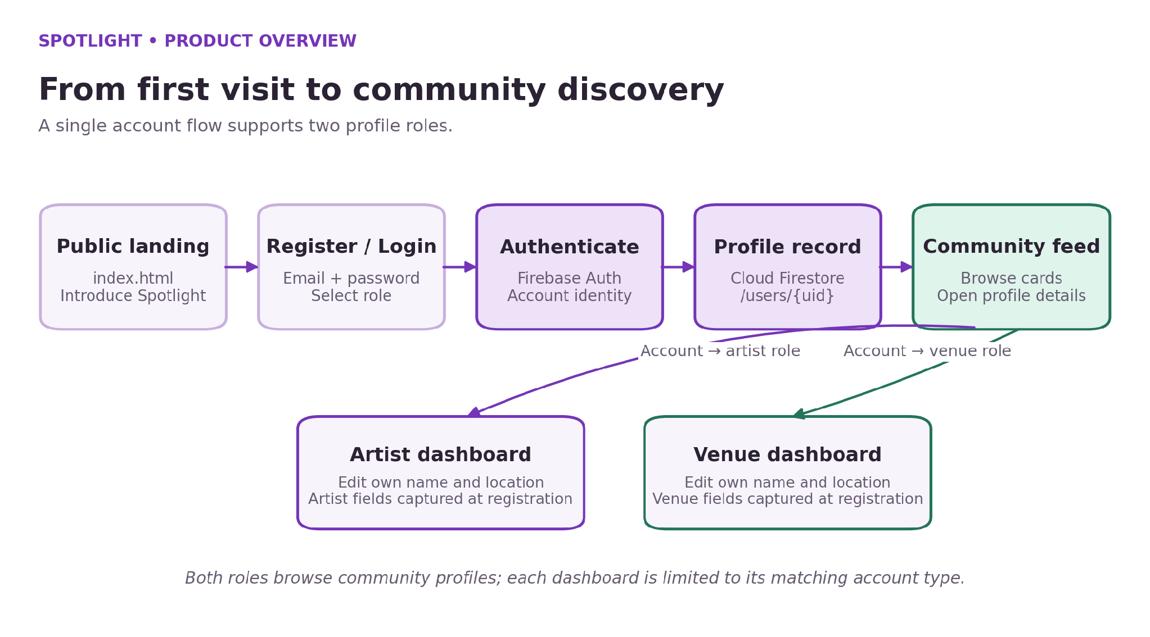
Figure: High-level user journey from the public landing page to role-specific account areas.

19 Feasibility, dependencies and risks
Risk register
The project is technically feasible as a small web prototype because the required user interface can be built with HTML, CSS and JavaScript, and Firebase supplies authentication and document storage without a custom server. Development can be performed in VS Code and tested using Live Server.
The key dependency is internet access and availability of Firebase services. The browser SDK and project configuration must be correct. Firestore rules must match the operations performed by registration, profile editing and the feed query. A profile field saved under one name will not appear if the UI reads a different field name.
Risks include profile information being incomplete, externally hosted images failing to load, permissions preventing feed queries, accidental changes to existing data and users creating test accounts with addresses that cannot receive reset emails. Mitigations include using test accounts, retaining a backup of the project folder, not changing rules blindly, displaying fallback images, validating input and clearly marking planned features.
Risk | Impact | Mitigation
Firestore rule mismatch | Feed or updates fail | Test exact read/write flows before publishing rules
External image unavailable | Blank or broken image | Use reliable direct image URLs and fallback initials
Test email cannot receive mail | Password reset cannot be completed | Use a real inbox when testing reset
Scope expansion | Core demo becomes unstable | Freeze features before presentation
Public data exposure | Privacy issue | Separate public profile fields from private email data

20 System architecture
Components
Spotlight uses a browser-first architecture. HTML defines the page structure, forms and navigation; CSS provides the dark-purple visual system and responsive layout; JavaScript validates inputs, handles clicks and submits asynchronous requests to Firebase. The current prototype does not include a custom application server or a server-side API layer.
Firebase Authentication manages account identity. Once a user has signed in, the authenticated UID identifies the matching Firestore document under the users collection. The feed reads the profile collection and separates documents by the accountType field, then builds the artist and venue cards from available profile fields such as name, location, category/type, description and image URL.
This architecture kept development manageable because authentication and cloud persistence did not require a separate server to be built. The trade-off is that the browser is not trusted: database security rules must enforce access. The discovery feed also creates a privacy design issue when public profile fields and email addresses live in the same document. The prototype demonstrates the feature, but the data model should be separated before a real public launch.
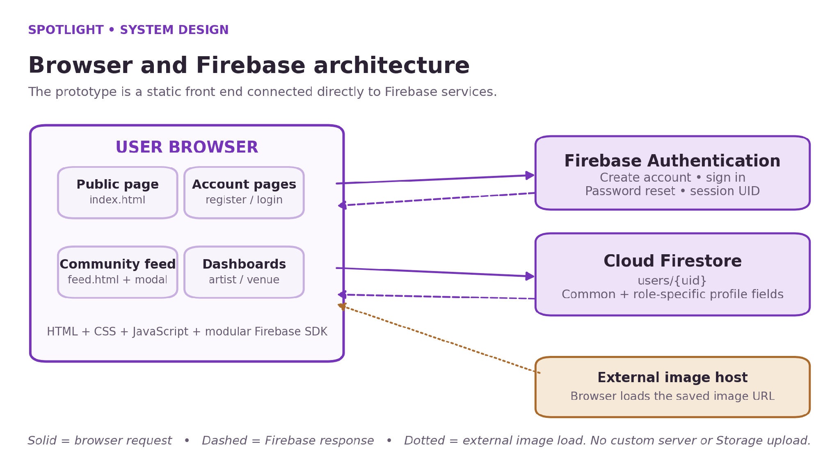
Figure: Browser and Firebase architecture used by the current prototype.

21 Architecture diagram and data flow
Data flow notes
The architecture diagram shows the responsibilities that are visible in the current implementation. The browser collects form values and renders results. Firebase Authentication verifies credentials and supplies the UID. Cloud Firestore stores and returns profile documents. The browser coordinates these services with the modular Firebase JavaScript SDK and handles successful responses or failures.
During registration, the form validates the required values, creates an Authentication account and uses the resulting UID when saving the profile document. During login, Firebase checks the credentials and the application reads the user’s profile to determine the role and the account link. For discovery, the feed requests profile documents and renders separate venue and artist sections. The precise availability of those documents depends on the published Firestore rules.
The same Firestore data can be read from another computer that connects to the same Firebase project, subject to authentication and security rules. Image fields store external web addresses; the browser loads the image from its host. They are not copies of image files inside Firestore, and they are not managed uploads in Firebase Storage.
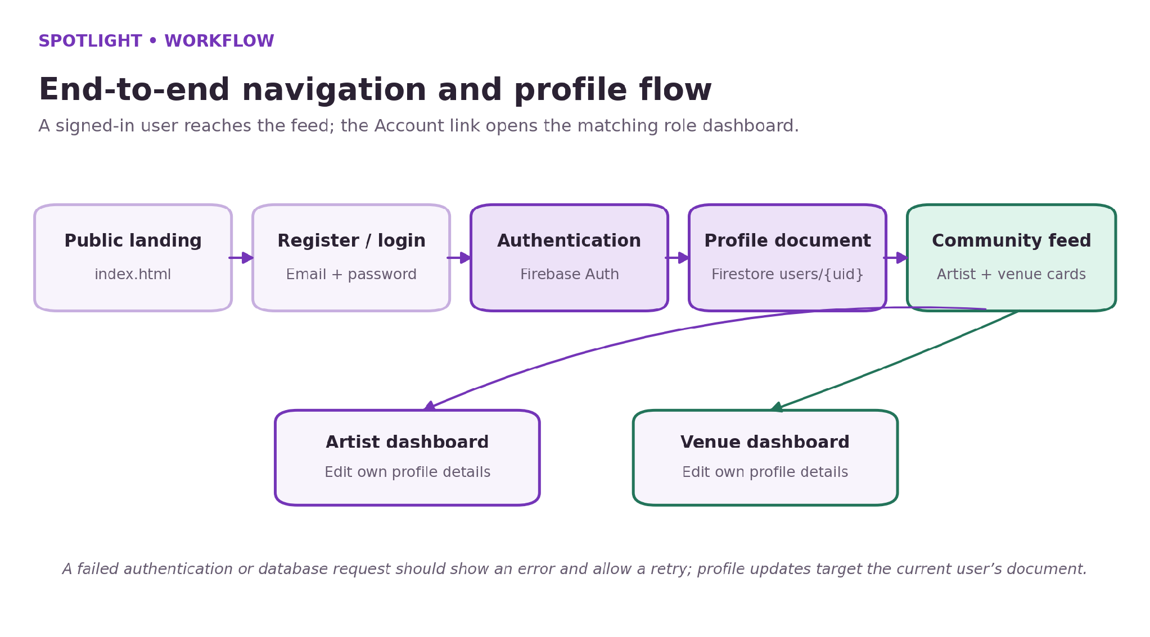
Figure: End-to-end navigation and profile flow, including the role-aware Account link.

22 Profile schema and conceptual model
Common and role-specific fields
Each account has a document in the users collection, addressed by the authenticated UID. Common fields include uid, email, fullName, accountType, location and createdAt. The document ID/UID association makes it straightforward for a dashboard to load the signed-in user’s profile and for the UI to choose the matching account area.
Artist-specific fields include artistCategory, description and profileImageUrl. Venue-specific fields include venueType, description, profileImageUrl and venueImageUrl. The current registration form captures these role-specific values, and the feed uses them when available. The account dashboards support editing the name and location, plus the available image URL fields in the current files; the role-specific category/type and description are not yet fully exposed as editable dashboard controls in every form. Older test records may lack newly introduced optional fields, so the UI should use sensible fallbacks.
The profile diagram describes the document structure used by the application, rather than a set of separate model classes. The code currently processes Firestore documents as JavaScript objects. The conceptual class diagram later in the report is a suggested refactor for a class-oriented implementation, not evidence that inheritance has already been coded.
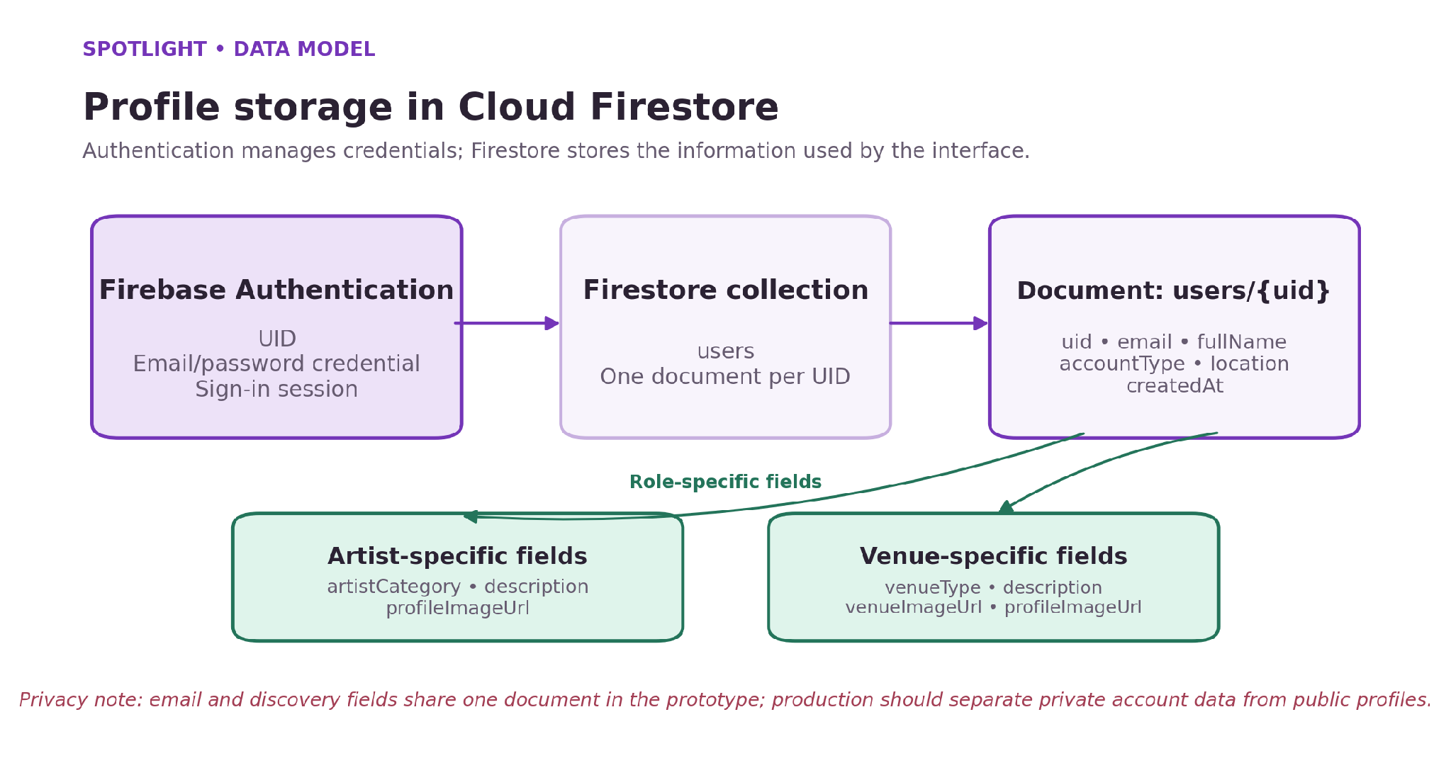
Figure: Firestore profile data model and role-specific fields.

23 Use-case UML diagram
Use-case boundary
The use-case diagram models the core interactions for the two actor roles. Artist and Venue / Event Organiser are separate actors because their profile fields differ, but they share most of the account lifecycle and discovery interactions.
Authentication is the entry point for the signed-in workflow. Browsing and viewing profile details allow a user to inspect other profiles. Editing is intended for the signed-in owner. Logging out ends the session and returns the user to the public entry experience.
The diagram is intentionally limited to features demonstrated in the prototype. It does not contain bookings, payments, messaging or notifications because those features require additional data structures, permissions and workflows.
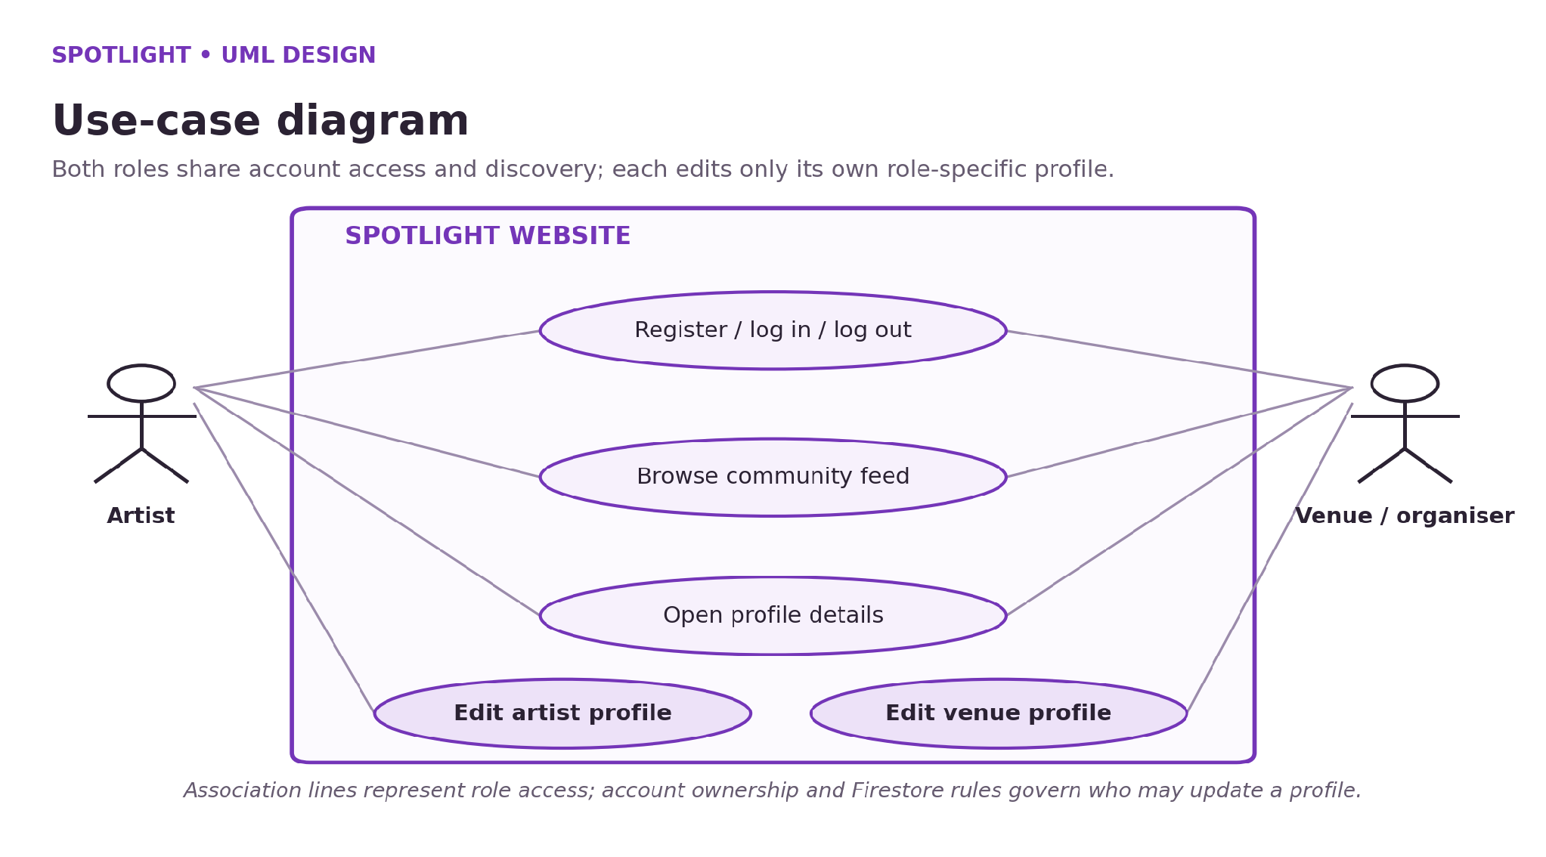
Figure: UML use-case diagram for shared actions and role-specific profile editing.

24 Sequence diagram: registration and discovery
Error handling in sequence
The sequence diagram separates the user, browser interface, Firebase Authentication and Cloud Firestore. The user submits registration details or login credentials through the UI. Authentication creates the account or verifies sign-in and returns the authenticated identity. The interface then writes or reads the associated profile record in Firestore. On feed load, it queries the profile collection and renders the results returned under the active security rules.
The returned accountType determines which dashboard link is shown, while the feed filters records into artist and venue groups. Profile cards use a photo when a supported image URL is present and a fallback icon or initial when it is missing or unavailable. The current UI uses a detail view for a selected card; the owner can be identified as viewing their own profile and directed to the account area.
These operations are asynchronous, so the interface must wait for Firebase to respond before claiming that an action succeeded. When an operation fails, the browser console can help the developer investigate, while the page should give the user a clear message and allow a retry where appropriate. One known edge case is a successful Authentication account creation followed by a failed Firestore profile write; a production version should offer a recovery path for that partial state.
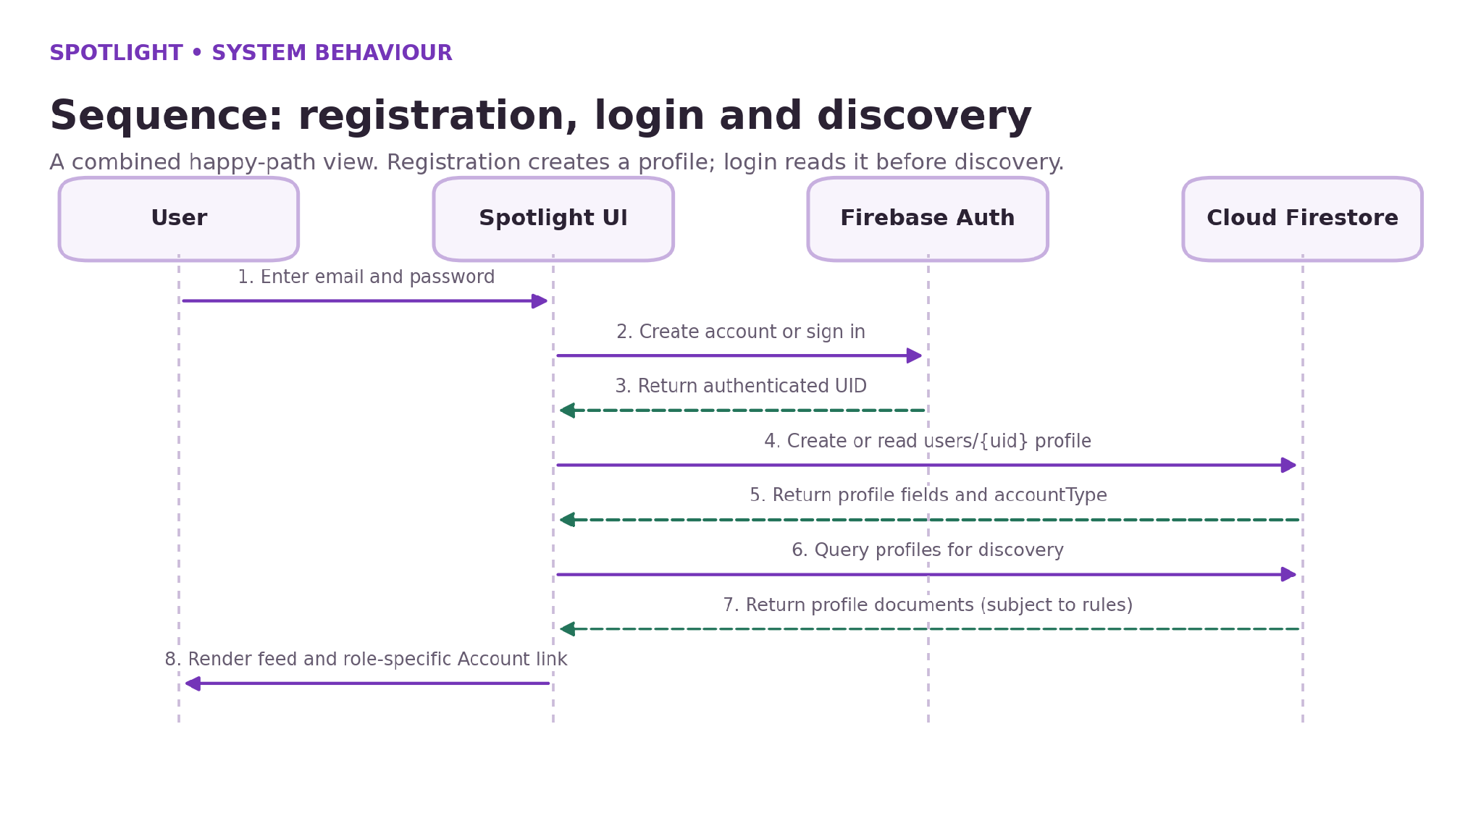
Figure: Sequence diagram for registration, sign-in and profile discovery.

25 Navigation map and page responsibilities
The application separates public introduction from the authenticated feed and from account dashboards. This makes the starting page useful for a first-time visitor while giving returning users a more functional page after login.
index.html introduces Spotlight and provides links to register or log in. register.html creates an account and its Firestore profile. login.html signs in, offers a password reset request and routes the user to the signed-in experience. feed.html shows the community sections and provides profile detail interactions. artist-dashboard.html and venue-dashboard.html read and edit role-specific profile data.
style.css styles the public homepage, while auth.css provides shared account-page styling. Some dashboards also contain page-specific CSS and JavaScript. script.js provides homepage session/navigation behaviour. The separation is not a full component framework, but it keeps major responsibilities identifiable.
File | Responsibility
index.html | Public landing page
register.html | Account registration and initial profile creation
login.html | Login and password-reset request
feed.html | Community feed and profile detail modal
artist-dashboard.html | Artist profile view and edit form
venue-dashboard.html | Venue profile view and edit form
style.css / auth.css | Page styling
script.js | Homepage authentication/navigation behaviour

26 Interface and UX design decisions
Design principles
The site uses a dark background, purple highlights and rounded cards to give the interface a consistent identity. The Spotlight logo uses a glitter texture and glow effect. Reusing shared CSS variables and styles helps keep button, label, input and header behaviour aligned across the public and account pages.
Forms use explicit labels, appropriate input types and required-field constraints. Passwords can be shown or hidden before submission. Submit buttons provide a loading label while a Firebase operation is running. Error and success messages help users understand the result. This is particularly important because cloud operations may fail because of network or rule configuration rather than user input alone.
The feed uses sections for venues and artists, matching the mental model of users browsing one type of profile at a time. Cards include a picture where available, a category/type pill, name and location. Clicking a card opens a larger profile detail view. The design can be enhanced later with search and filtering, but a small number of predictable controls is appropriate for the initial demo.
- Consistency: shared visual language and repeated components.
- Visibility: clear action labels and status messages.
- Progressive disclosure: profile details open from a card.
- Fallbacks: default display when optional imagery is unavailable.
- Scope honesty: future features are labelled as planned.

27 Implementation overview
Implementation sequence
The project is implemented as a collection of static HTML pages with embedded JavaScript modules and external stylesheets. The code is intentionally lightweight: the browser loads Firebase SDK modules from Google’s CDN and connects to the configured Firebase project. Local development uses VS Code and Live Server.
The implementation was developed iteratively. The public homepage and styling were prepared first. Firebase Authentication was configured for email/password sign-in. Cloud Firestore was created and security rules were added. Registration was connected to Authentication and Firestore, then the login flow and dashboards were connected. The feed was later updated to retrieve artist and venue profiles.
Each stage depends on the prior stage. Authentication provides a UID, Firestore stores a document under that UID, dashboards use the UID to read and update the profile, and the feed retrieves profile records to display community cards. Testing therefore focused on the complete flow rather than isolated visual components.
1. Build public landing page and navigation.
2. Register Firebase web app and configure email/password authentication.
3. Create Firestore database and profile collection pattern.
4. Connect registration and login to Firebase.
5. Build artist and venue dashboards.
6. Build feed query, profile cards and profile detail view.
7. Test profile edits, navigation, logout and data persistence.

28 Project file structure
The project folder contains the main HTML pages, shared CSS files, JavaScript and a logo texture asset. Keeping all these files inside one folder makes it simple to open the project in VS Code and run it through Live Server. The code does not require a package installation or bundler in the current configuration.
The structure is intentionally small. The HTML files include their own Firebase module code where needed. This avoids build configuration, but it also duplicates the Firebase configuration across several files. A future version could centralise shared Firebase initialisation into one JavaScript module to reduce duplication and make updates safer.
The glitter.png asset must remain in a path that the CSS can resolve. Relative links such as login.html, register.html and feed.html are expected to work when served from the same project directory. Opening files directly with the file:// scheme can break ES module imports; use Live Server instead.
File | Purpose
index.html | Public homepage
feed.html | Signed-in community feed
login.html | Login and password reset
register.html | Artist / venue account registration
artist-dashboard.html | Artist profile dashboard
venue-dashboard.html | Venue profile dashboard
style.css | Homepage styles
auth.css | Shared account and dashboard styles
script.js | Homepage navigation logic
glitter.png | Logo texture asset

29 Public homepage implementation
Primary design elements
The public homepage communicates the core message, “Your Talent. Your Stage.” It introduces Spotlight as a place where artists meet opportunities and gives visitors two clear routes: register as an artist or register as a venue. Visitors can also navigate to login and view the sections that explain the concept.
The page uses a shared brand system: a glitter-textured logo, dark background, purple primary buttons, outlined secondary buttons, and content cards. It is intentionally a public entry point rather than the signed-in discovery page. Separating the landing page and feed allows a first-time visitor to understand the product before interacting with profile data.
The screenshots in this report are genuine development captures of the prototype. They should be treated as evidence of the interface at the time captured, not necessarily as the exact final layout after every later adjustment.
- Brand headline and local creative-community statement.
- Separate artist and venue call-to-action buttons.
- Navigation for login and getting started.
- Consistent visual language with the signed-in feed.
Figure: Public landing page during development.

30 Registration and login interface
Account access
The registration form collects the user’s account type, full name, email, password and location. The account type determines which role-specific profile fields are relevant. For example, artist profiles use an artist category and venues use a venue type. Optional description and image URL fields allow the user to provide information for display in discovery cards.
The password field has a Show/Hide control to help users review the value they entered. The form validates required fields and uses Firebase Authentication to create the account. After a successful account creation, the profile document is written to Cloud Firestore. If a write fails after authentication succeeds, the account may exist without a complete profile and requires an explicit recovery path.
The login page authenticates the user using email and password. The Forgot Password control sends a reset request through Firebase Authentication. This feature only helps if the email address can receive messages and the project’s email action configuration permits delivery.
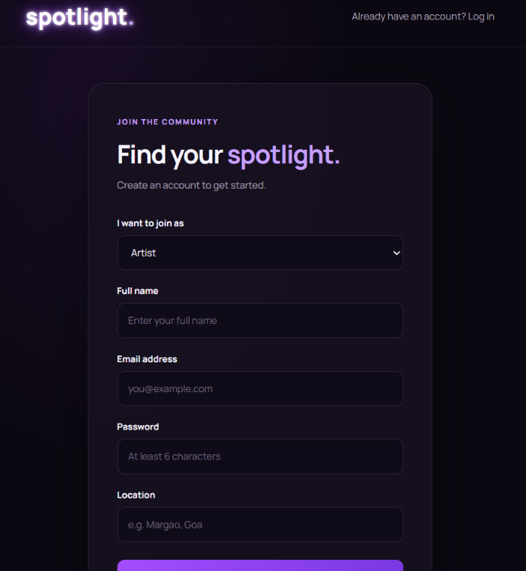
Figure: Registration form with artist/venue account selection.

31 Authentication implementation
Authentication lifecycle
Firebase Authentication is used rather than storing passwords in Firestore. During registration, createUserWithEmailAndPassword creates the authentication account and returns a user object containing a UID. The application updates the display name and writes a profile document whose path uses that UID.
During login, signInWithEmailAndPassword checks the submitted email and password. Firebase maintains the authentication session for the browser. The website uses the authenticated user to read the corresponding profile and determine whether the Account link should lead to the artist or venue dashboard. Logout calls signOut and redirects to the public homepage.
User-facing errors are mapped from Firebase error codes where possible. Invalid credentials, invalid email formats, network failures, rate limiting and disabled providers require different messages. Password reset requests should not expose whether a particular email address belongs to an account; the interface can use a generic confirmation message.
1. Collect login credentials from the form.
2. Call Firebase Authentication.
3. On success, read the profile document.
4. Use the accountType field to set account navigation.
5. On logout, end the session and return to the public page.
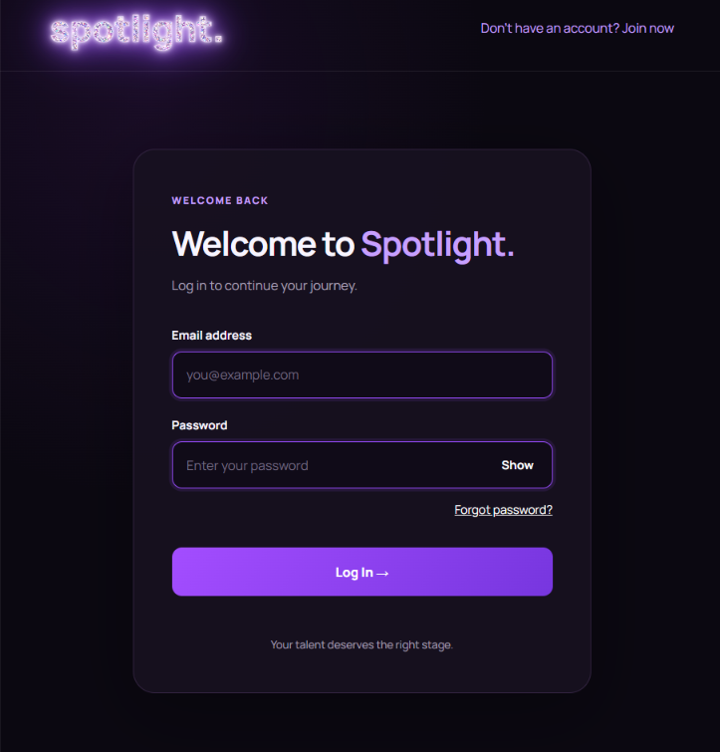
Figure: Login interface with password visibility and reset option.

32 Cloud Firestore profile storage
Example profile structure
Cloud Firestore stores a profile document under the users collection. The application uses the authenticated UID as the document identifier, which makes the owner’s profile easy to locate. Common fields include uid, email, fullName, accountType, location and createdAt. Role-specific fields are saved in the same document in the current prototype.
Profile updates call updateDoc with the changed fields. The application then refreshes the on-screen profile and updates the Firebase Authentication display name where appropriate. Firestore persistence enables the same data to be read after refreshing the page or signing in on another device, provided that the device connects to the same Firebase project and reads are allowed.
Firestore security rules determine which documents a client can read or change. A feed that queries the whole users collection requires broader read permissions than a dashboard that reads only the current user’s document. For a production system, public profile fields should be stored separately from private email data, and rules should be designed around each data category.
Field | Purpose
uid | Links profile document to authenticated user
email | Account email; treat as private
fullName | Profile display name
accountType | artist or venue
location | City or area
artistCategory / venueType | Role-specific classification
description | Short public-facing profile text
profileImageUrl / venueImageUrl | External image URL

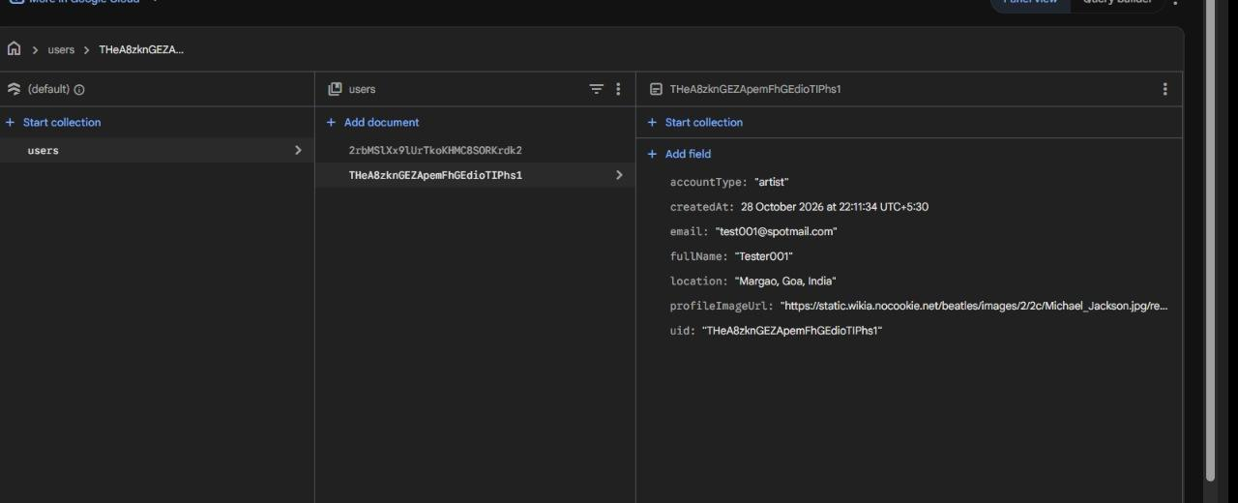
Figure: Firestore user profile document as captured during development.
33 Community feed implementation
Rendering logic
The signed-in feed contains separate Explore Venues and Discover Artists sections. The JavaScript uses the Firestore SDK to retrieve profile documents, then separates them according to accountType. Venue cards prefer venueImageUrl and fall back to profileImageUrl. Artist cards use profileImageUrl. If no image is provided or the remote host fails, the card uses a symbolic fallback.
The card layout includes a visual, a role/category pill, a name, a location and a short description. The feed uses safe text assignment for user-provided strings so descriptions are treated as text rather than inserted as arbitrary HTML. Clicking a card opens a profile detail modal with a larger image, details and a link to edit the current user’s own profile when applicable.
Feed loading depends on Firestore permissions. If read rules reject the query, the page displays an error message rather than claiming that there are no profiles. This distinction helps separate an empty community from a database access failure.
- Query profile documents from Firestore.
- Split documents into venue and artist groups using accountType.
- Create DOM cards from the stored profile fields.
- Show profile details on card selection.
- Display a useful message if the query fails.
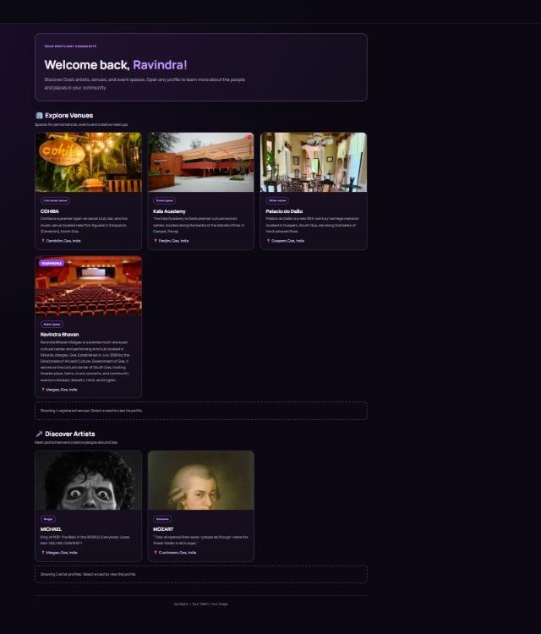
Figure: Community feed showing venue cards and artist profiles.
34 Profile cards and detail modal
Modal behaviour
The feed cards provide a compact preview. The detail modal provides additional context without requiring a separate route for every profile. It shows the profile image when one is available, the name, location, category or venue type, and a short description. The modal can be closed with its close button, by selecting the backdrop, or with the Escape key.
For the signed-in user’s own profile, the modal can identify the card as the user’s profile and provide a route to the account dashboard. For other profiles, the public detail view should avoid revealing private account fields such as email. This supports the intended discovery experience while limiting unnecessary exposure.
This design is suitable for an initial prototype because it offers a richer profile view without requiring separate profile routing or complex client-side state. A future version could replace the modal with unique public profile routes and provide shareable links, while keeping public and private fields separate.
- Open by clicking or keyboard-selecting a profile card.
- Show category/type and location labels.
- Use the profile description or a fallback message.
- Do not show email addresses in the public view.
- Allow the owner to navigate to Edit Profile.

35 Artist dashboard
Main interface areas
The artist dashboard presents the signed-in user’s profile summary, including display name, email for the owner, account type, location and a profile image when a valid URL is available. The Edit Profile control reveals an editing form. In the current version the form supports changing the full name and location, and it includes a profile image URL field. Artist category and description are collected during registration and shown in discovery where available, but are not fully editable through this dashboard form yet.
On dashboard load, the page checks Firebase Authentication state. A visitor who is not signed in is redirected to the login page. The dashboard reads the corresponding Firestore document and checks accountType; an account of the other role is redirected to the matching dashboard. If the expected profile record is missing or unreadable, the page shows a message rather than pretending that the record loaded.
When the owner clicks Edit Profile, the editing form becomes visible. On save, the page validates the supported fields, updates the owner’s Firestore document, updates the Firebase Authentication display name when needed, and refreshes the visible profile summary. The success message is shown only after the awaited operations finish. This is a basic profile-management workflow, not a complete public artist portfolio editor.
- Profile summary and avatar/image.
- Account type and location display.
- Edit Profile button and form.
- Save confirmation or error message.
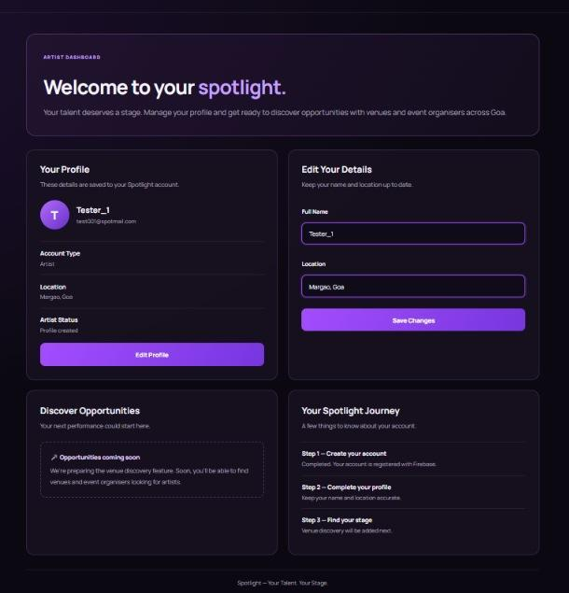
Figure: Artist dashboard with profile summary and editable fields.
36 Venue dashboard
Venue-specific information
The venue dashboard follows the same overall layout while showing venue-specific information. The registration flow captures the venue type, description, profile image URL and venue photo URL along with the common name, email and location fields. The dashboard supports editing the name and location, and the current version also exposes profile/venue image URL fields. Venue type and description are used by discovery when present, but the dashboard does not yet provide a complete event-posting or booking-management interface.
Role selection is stored in accountType when the profile is created. The dashboard checks this field to avoid showing the wrong account area. Ordinary profile updates are expected to preserve the original UID and accountType, so a user cannot convert an artist account into a venue account by editing the profile form.
The current MVP does not publish event posts, event calendars, booking slots or confirmed availability. Venue accounts maintain a discoverable profile, and those profiles can be shown to signed-in artists. This creates the groundwork for a later opportunity model without claiming that a venue-to-artist transaction currently takes place.
- Venue type: examples include live music venue, restaurant/café, bar/club or event space.
- Venue description: short summary of the space or events hosted.
- Venue image URL: external image address for the discovery card.
- Location: city/area for local discovery.
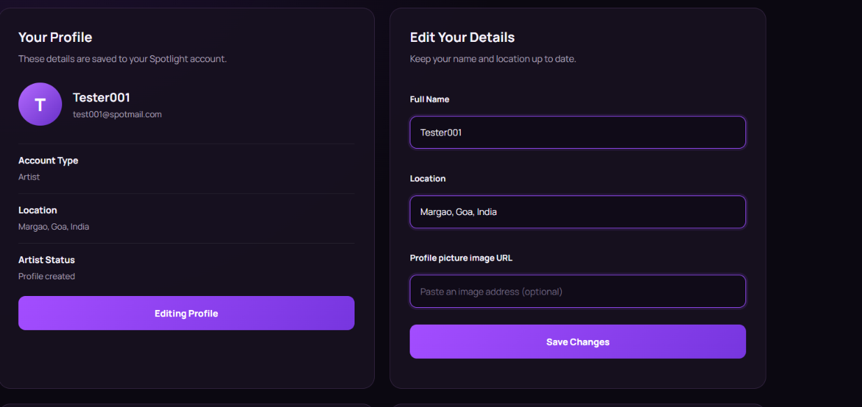
Figure: Profile image and venue photo URL controls in the current prototype. Image URLs are saved as text; this is not a direct file-upload interface.

37 Profile updates and image handling
Current implementation versus future approach
Profile updates are written to Firestore through an updateDoc call using the current user’s document reference. The app also updates the Firebase Authentication display name so that the identity shown by Authentication stays aligned with the profile name. After the write completes, the UI refreshes with the returned form values and displays a success message.
The image field accepts a web address that points to an externally hosted image. The browser loads the image separately from Firebase; Firestore stores the URL string only. This reduces implementation complexity for the prototype but introduces a dependency on the image host and does not guarantee long-term availability.
Direct upload was deferred for the MVP because it adds storage configuration, file type and size validation, upload progress, deletion/lifecycle decisions and additional security rules. Firebase’s current Cloud Storage requirements should be checked before a future implementation; this report does not claim that the current build uploads images to Firebase Storage.
Current MVP | Possible future approach
Paste image URL | Select file from device
Store URL as Firestore string | Upload file to managed cloud storage
External host controls availability | Application controls object access and lifecycle
Basic URL validation | Validate image MIME type, size and permissions

38 Error handling and validation
Validation considerations
The project uses browser form validation for required fields, email format and a minimum password length. JavaScript trims text fields where appropriate and validates that accountType contains one of the supported roles. Submit buttons are disabled temporarily during asynchronous operations to prevent duplicate requests and show a processing label.
Firebase operations can fail for different reasons. Examples include an email already in use, an invalid credential, a weak password, network failure, too many attempts or a Firestore permission error. Good user feedback should describe the action that did not complete and should avoid presenting a partial operation as fully successful.
A possible partial-registration scenario occurs when Firebase Authentication creates an account but the subsequent Firestore profile write fails. The authentication account may remain even though the profile document is missing. A more complete production workflow could add a recovery screen that guides the user to retry profile creation or contact an administrator.
- Validate required values before calling Firebase.
- Handle authentication and Firestore errors separately.
- Do not expose stack traces or secret data in the interface.
- Use console logging only for development diagnostics.
- Retest form controls after any CSS or JavaScript changes.

39 Security and privacy considerations
Security recommendations
Firebase web configuration is included in the front-end code because it identifies the project that the browser connects to. It should not be confused with a service-account private key. Security must be enforced with Firebase Authentication and database rules rather than by hiding the client configuration.
The community feed reads documents belonging to users other than the signed-in user. A rule that permits only owner reads will therefore block the collection-wide discovery query. During the demo, the rules were adjusted so authenticated users could read the profile collection. Because the users documents also contain email addresses, this approach exposes more data than a production community feed should reveal. The current rules should be treated as demo-only and not copied into a public deployment unchanged.
A more robust design would separate private account metadata into a restricted users document and publish only the fields required for discovery in a publicProfiles collection. Profile writes should remain owner-only, and ordinary users must not be able to change UID or accountType. Administrative deletion/moderation should use a trusted backend with server-side privileges; secret admin credentials must never be placed in the browser.
This limitation is recorded deliberately rather than hidden. The prototype proves that the feed and cloud profile flow can work, while the production design still needs a least-privilege public/private data split and explicit access-rule tests for every collection.
- Keep public fields separate from private account fields.
- Allow profile edits only to the owner.
- Prevent ordinary users from changing uid and accountType.
- Never place service-account private keys in front-end code.
- Review rules whenever a new collection query is introduced.

40 Testing approach
Test environment
Testing was carried out manually in a browser using Live Server and the configured Firebase project. The purpose was to verify the essential user journey rather than claim production-scale performance. The checks covered registration, sign-in, profile persistence, the role-aware dashboards, feed discovery, profile-card images, updates and logout.
Separate artist and venue test accounts were used. Firebase Authentication was checked to confirm account creation, and Firestore Data was checked to confirm that each account had a profile document under its UID. The feed was then tested with the signed-in session to verify that profile records appeared in the correct section.
Visual checks covered the public landing page, registration and login forms, password visibility control, the dark-purple theme, community cards, profile detail view and dashboard layout. Image URLs were tested in the interface. Their display is conditional because an external host can block embedding, change an address or remove a file even when the URL once opened directly in a browser. Names and images used in test cards are illustrative demonstration content, not endorsements or proof of formal partnerships; a public release should use approved images and real, consented profiles.
An important debugging step was resolving the difference between owner-only Firestore reads and the collection query required by discovery. The first rules prevented the feed from retrieving other accounts. After the read permissions were adjusted for the demo, venue and artist records appeared in the feed. This fix demonstrated the relationship between frontend queries and database authorisation, while also revealing the privacy trade-off described in the security section.
- Visual Studio Code with Live Server.
- Web browser with internet access.
- Firebase Authentication and Cloud Firestore.
- Separate test accounts for artist and venue roles.

41 Functional test cases
The following cases summarise the core tests relevant to the current MVP. “Observed” describes the development checks reported during the project; it is not a claim of automated test coverage. Repeat these checks in the extracted final project before the evaluation.
ID | Test | Expected result | Observed status
TC-01 | Open public homepage | Landing page and navigation render | Passed manually
TC-02 | Register artist account | Auth account and profile document created | Passed manually
TC-03 | Register venue account | Venue role and profile fields stored | Passed manually
TC-04 | Login with valid account | User is signed in and feed opens | Passed manually
TC-05 | Edit profile and save | Firestore fields update | Passed manually
TC-06 | Feed query | Artist and venue profiles display | Passed after rule adjustment
TC-07 | Display image URL | Image appears if host allows embedding | Conditional
TC-08 | Logout | Session ends and public page opens | Passed manually
TC-09 | Password reset | Reset email sent to reachable inbox | Requires real email test

42 Test results and evidence
Evidence summary
The most important observed result was the end-to-end profile flow: registration created an authenticated account and a Firestore user document, and the user could log in and see profile information. Manual profile edits were saved back to Firestore and reflected in the dashboard after saving.
The feed initially displayed a permissions error because the original Firestore rules restricted reads to the current user’s document. The feed was designed to query the users collection in order to display both artist and venue profiles. The rules were then adjusted during development so signed-in users could read profiles, after which the screenshot showed registered venue and artist cards.
Images displayed when a usable direct image URL was saved and the remote host permitted embedding. This confirms that the UI can render URL-based images; it does not demonstrate upload to Firebase Storage. The testing evidence supports the basic prototype workflow while highlighting the need to improve public/private data separation and image handling before production.
- Authentication accounts are visible in Firebase Authentication.
- Profile fields are stored in Firestore documents.
- The feed shows registered profile cards.
- Image display depends on the remote image URL.
Figure: Feed after profile records were loaded from Firestore.

43 Usability observations
Observed UI refinements
The most visible usability improvement was the separation between the public landing page, the signed-in feed and the account dashboard. A first-time visitor sees an introduction before signing in. A returning user sees the feed. The Account link provides access to the editable profile, while Log Out ends the authenticated session.
The profile edit form was changed to remain hidden until the user clicks Edit Profile. This keeps the initial dashboard focused on viewing profile information and reduces visual clutter. The “Show” button in password fields makes it possible to verify the entered password. Button cursor states and disabled states were also adjusted to better communicate when an operation is available or in progress.
The feed is still sparse when there are only a few profiles. This is acceptable for a prototype if the interface displays real registered profiles and does not pretend that sample cards are actual partners. Empty-state messages and clearly labelled future features help communicate the stage of development.
- Clear public versus signed-in navigation.
- Role-specific dashboards.
- Edit mode revealed only on user action.
- Fallback for missing images and descriptions.
- Honest labelling of future features.

44 Results and discussion
Overall outcome
The current result is a working prototype that establishes the platform’s account and profile foundation. It proves that the same Firebase project can hold multiple user accounts, store profile data and provide a signed-in interface that retrieves and displays profiles when rules permit it.
The implementation also demonstrates a clear distinction between identity data and the discovery experience. Firebase Authentication verifies the account, whereas the Firestore document supplies descriptive profile attributes such as category, location and image URL. This split is useful in the design, but the current single-collection approach still requires privacy refinement.
The most important limitation is the gap between initial discovery and a complete marketplace workflow. The feed can show profile cards, but it does not yet manage availability, event posts, application status, booking confirmation or direct communication. These capabilities require additional data models and user journeys. The prototype is therefore a foundation and proof of concept, not a finished commercial platform.

45 Project development activities
Work phases
The work was carried out as a sequence of short implementation and test cycles. First, the public homepage and visual identity were developed. Registration and login pages were then added and connected to Firebase Authentication. Cloud Firestore was created to store user profile data, and the security rules were adjusted to support the operations performed by the interface.
The next phase added role-specific dashboards and profile editing. Profile fields were expanded to include artist category, venue type, description and image URLs. The feed was then updated to load registered profiles rather than displaying only static placeholder cards. Profile detail interactions and account navigation were refined, and screenshots were captured during testing.
The process included debugging CSS conflicts, navigation mistakes, image URL issues and Firestore read permissions. These iterations illustrate a normal development cycle: identify a problem from the UI or console, inspect the related code or data, apply a focused change, and retest the complete flow.
1. Concept and UI layout.
2. Firebase project setup and web app registration.
3. Authentication and initial profile data.
4. Artist and venue dashboards.
5. Feed and card rendering from Firestore.
6. Profile detail and image URL support.
7. Manual validation, documentation and presentation.

46 Development timeline and activity record
The timeline is reconstructed from the project files, console setup steps and screenshots available during preparation. It records the development sequence rather than inventing exact hours. The main milestones were page design, Firebase project setup, email/password authentication, Firestore profile writes, role-specific dashboards, feed discovery, bug fixing and final documentation.
The work required repeated short test cycles because an apparent UI issue could originate in styling, navigation, stored field names or database rules. Useful checkpoints were: a registration account appears in Authentication; the matching document appears in Firestore; login succeeds; the correct role dashboard opens; profile changes persist; and the feed renders records from both roles.
To keep the submission manageable, features requiring new workflows and service dependencies were left for future scope. The report records these boundaries openly. This is preferable to describing unfinished booking, upload or notification flows as if they had been tested.
Phase | Activity | Result / artifact
1 | Plan brand and user roles | Landing-page concept and role-specific paths
2 | Create Firebase project | Web app and Authentication configured
3 | Create Firestore | users collection document pattern established
4 | Connect account forms | Registration/login working
5 | Build dashboards | Profile read and edit flow
6 | Build feed | Artist/venue cards from cloud records
7 | Debug and verify | Permissions, navigation and image handling refined
8 | Prepare submission | Presentation, report, screenshots and demo plan

47 Tools, technologies and learning outcomes
Learning outcomes
HTML was used to define the page structure, forms, navigation and profile cards. CSS provided the dark-purple theme, responsive grids, card styling, logo texture and password control positioning. JavaScript handled validation, event listeners, navigation, DOM rendering and asynchronous calls to Firebase services.
Firebase Authentication was used for email/password account management. Cloud Firestore was used for profile documents. Visual Studio Code provided the development environment and Live Server served the pages during local testing. The Firebase Console was used to configure the project, enable Authentication and inspect profile documents and rules.
The project reinforced the importance of separating UI concerns from cloud operations, matching the Firestore field names to the UI, handling asynchronous failures, and understanding that authentication and database authorization are different. It also highlighted the need to define a realistic MVP and leave complex features for later rather than jeopardising a working demo.
- Design a multi-page browser application.
- Connect frontend forms to cloud authentication.
- Store and retrieve document-based profile data.
- Debug permission errors and inconsistent field names.
- Design a role-aware navigation flow.
- Document tested features and limitations accurately.

48 Limitations of the current prototype
Limitations are intentional scope boundaries
The prototype is a profile-discovery MVP, not a full artist marketplace. It does not include an event availability calendar, booking request lifecycle, payments, direct messaging, in-app notifications, reviews or moderation workflow. Browsing a profile does not create a booking or guarantee that an artist or venue is available.
Images are referenced through URL strings. A URL can work when opened directly but still fail when embedded in another page due to host policy, and the host can change or remove the image. Direct upload, managed storage, upload validation and the deletion lifecycle are outside this build.
The signed-in feed requires read access to multiple profile records, while the current users collection also contains email fields. This prototype configuration is not suitable as-is for a public launch. A production version should split public discovery fields from private account information, review access rules, add a trusted moderation process and test the rules against both expected and unauthorised requests.
Testing is manual and focused on the main browser workflow. There is no automated test suite, formal performance benchmark, full accessibility audit or production deployment included in this report. The profile dataset is also small and includes demonstration records, so the feed has not been evaluated for a large community.
- No bookings, payments, messages or notifications.
- No direct image upload to managed storage.
- External image URLs may fail.
- Public/private profile separation needs improvement.
- No automated tests, moderator console or production deployment.

49 Future scope and enhancements
Suggested roadmap
The next release should separate public discovery fields from private account data. A publicProfiles collection could hold only approved display fields, while email and authentication-related data remain restricted. The rules should be tested separately for public reads and owner-only updates.
Image handling could be upgraded to direct file uploads after storage access and billing requirements are checked. The workflow should validate file type and size, show progress, handle failures and prevent unauthorised overwrites.
A later release could let venues publish opportunities with title, date, location, required artist category and application instructions. Artists could submit interest and track an application state. Booking, messaging, map search, recommendations, moderation and public HTTPS deployment should follow only after the core data model and permissions are stable.
- Separate public and private profile data.
- Add validated image uploads.
- Add venue opportunity listings and artist interest/application.
- Introduce messaging and booking states.
- Add moderation, report tools and stronger privacy controls.
- Deploy and test with real artists and venues.

50 Object-oriented modelling and project explanation
Possible future class model
The product has clear domain concepts: User Account, Artist Profile and Venue Profile. These concepts are useful for UML modelling because they describe different roles and the information each role owns. The common profile attributes include UID, name, account type and location, while artist and venue records add role-specific fields.
The submitted application is mainly a browser-based JavaScript implementation using functions, event listeners, JavaScript objects and Firebase document records. The class model in this report is conceptual: it shows how a future OOP refactor might separate common account data from artist- and venue-specific data. It should not be interpreted as evidence that the prototype already implements a complete inheritance hierarchy with JavaScript classes.
For a viva, the accurate explanation is that the current code separates responsibilities across page files and functions, uses structured profile objects and selects role-specific UI based on accountType. These are useful design ideas, but formal inheritance and polymorphic class methods are not implemented. If class-based OOP becomes a required extension, a base Profile class could hold common fields and ArtistProfile/VenueProfile classes could specialise the role-specific attributes and validation.
Concept | Possible members / responsibilities
SpotlightUser | uid, email, fullName, accountType, location
ArtistProfile | artistCategory, description, profileImageUrl
VenueProfile | venueType, description, venueImageUrl
ProfileService | loadProfile(), updateProfile(), validate fields
DiscoveryService | loadProfiles(), filter by accountType, prepare cards
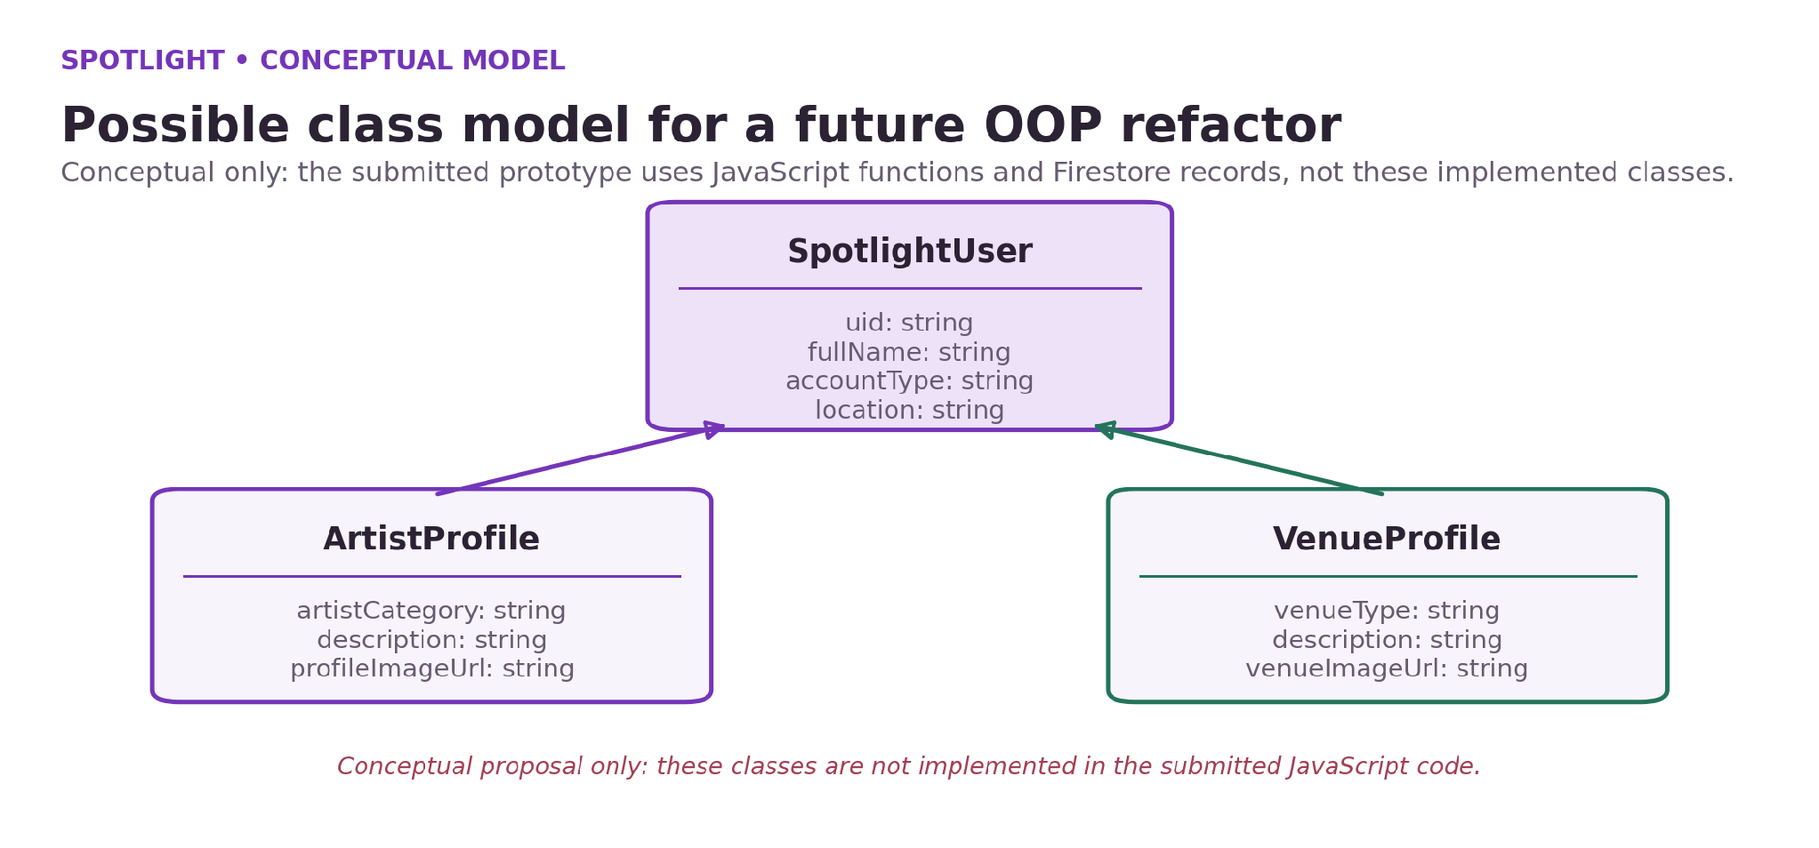
Figure: Conceptual class model for a possible OOP refactor; not implemented as live JavaScript classes.

51 Conclusion
Final statement
Spotlight was built as a browser-based prototype for connecting artists with venues and event organisers in Goa. It separates the public introduction, signed-in community feed and role-specific dashboards. Firebase Authentication manages email/password identity, while Cloud Firestore stores the profile records used by account pages and discovery cards.
The key result is an end-to-end account and discovery flow: users can register under a role, sign in, view artist and venue profiles, update supported account details and see cloud changes persist. The product was improved by testing real browser interactions, debugging navigation and image URLs, and aligning the Firestore rules with the feed query.
Spotlight remains a minimum viable product. Direct file upload, bookings, messages, notifications, moderation, automated recommendations and production-grade public/private profile separation are future work. Recording these limitations makes the demonstration easier to explain and provides a realistic next-step plan for a larger version of the platform.
- Spotlight demonstrates the core account and profile workflow.
- The feed displays available artist and venue records.
- Manual tests verified the key flow during development.
- The next stage should focus on privacy, image uploads and real opportunities.

52 References
The project description is based on the Spotlight HTML, CSS and JavaScript files, the Firebase configuration workflow and development screenshots available for the submission. The external references below provide technical background for browser technologies and Firebase services. Documentation was reviewed on 29 October 2026; URLs should be rechecked if this report is reused later.
Reference | Use in project
MDN Web Docs. HTML: HyperText Markup Language. https://developer.mozilla.org/docs/Web/HTML | HTML structure, semantic elements and form controls.
MDN Web Docs. CSS: Cascading Style Sheets. https://developer.mozilla.org/docs/Web/CSS | Layout, responsive styling and visual presentation.
MDN Web Docs. JavaScript. https://developer.mozilla.org/docs/Web/JavaScript | DOM interaction, events, async functions and modules.
Firebase Documentation. Firebase Authentication. https://firebase.google.com/docs/auth | Email/password authentication and account management.
Firebase Documentation. Cloud Firestore. https://firebase.google.com/docs/firestore | Document database concepts and SDK operations.
Firebase Documentation. Security Rules. https://firebase.google.com/docs/firestore/security/get-started | Access control and read/write rules for Firestore.
Spotlight project source files. HTML, CSS, JavaScript and README. | Primary evidence for the implementation and project scope.
Spotlight development screenshots, captured October 2026. | Visual evidence for the interface and Firebase data.
Firebase Documentation. Get started with Firebase Authentication on websites. https://firebase.google.com/docs/auth/web/start | Email/password account creation, sign-in and authentication state.
Firebase Documentation. Cloud Firestore data model. https://firebase.google.com/docs/firestore/data-model | Collections, documents and field-based profile storage.
Firebase Documentation. Writing conditions for Cloud Firestore Security Rules. https://firebase.google.com/docs/firestore/security/rules-conditions | Authentication and ownership conditions in database access rules.
Firebase Documentation. Cloud Storage for Firebase: billing and plan requirements. https://firebase.google.com/docs/storage/faqs-storage-changes-announced-sept-2024 | Storage-plan considerations behind deferring managed direct image uploads.

53 Appendix A: Product screenshots
A1. Public landing page
These screenshots document the main user-facing pages and selected development evidence. Profile names and images shown in demonstration records are test content, not evidence of formal partnerships or endorsements. Any image taken from a third-party website should be replaced with an image the project team owns or is authorised to use before public deployment.
A1. Public landing page.

54 Appendix A: Authentication screenshots
A2. Login interface
The registration form collects a role and basic profile details. The login page supports Firebase email/password authentication and a password-reset request. Password reset should be demonstrated only with an inbox that can receive the message.
A2. Login interface.

55 Appendix A: Community feed screenshot
A3. Community feed
The feed shows separate sections for venue and artist profiles. It renders images from saved URLs when the external host allows embedding. Profiles are generated from the Firestore records returned to the signed-in feed.
A3. Community feed showing venue and artist cards.

56 Appendix A: Artist dashboard screenshot
A4. Artist dashboard
The dashboard displays the saved profile summary and account fields. The edit form can be revealed when the user selects Edit Profile, and saved changes are written to Firestore.
A4. Artist dashboard and profile editing layout.

57 Appendix A: Firestore profile screenshot
A5. Firestore evidence
Firestore documents store the user’s profile information. The document uses the authenticated UID as its ID. The report does not include passwords; Firebase Authentication manages credentials separately from the profile document.
A5. Firestore user profile document captured during testing.

58 Appendix C: User guide
For a new artist or venue
This guide covers the primary interactions available in the prototype. The exact field set may depend on the latest page version, but the account and discovery sequence is the same.
1. Open the public landing page.
2. Choose Get Started or the relevant artist/venue registration button.
3. Select the account type and enter name, email, password and location.
4. Add optional role-specific fields if offered by the current registration form.
5. Submit the form and check for the success message.
6. Log in with the same credentials.
7. Use the feed to discover other registered profiles.
8. Select Account to open the appropriate dashboard.
9. Click Edit Profile to change supported profile fields.
10. Save changes and verify the displayed profile is updated.
11. Use Log Out when finished.

59 Appendix D: Viva preparation questions
The following questions and brief answer points can help the student revise. Expand each answer in their own words during the viva, and refer to actual project code when asked to demonstrate a detail.
Question | Answer points
What is Spotlight? | A browser-based artist/venue profile and discovery prototype for Goa.
Why Firebase? | Provides authentication and document storage without a custom server.
What is Authentication? | Verifies user identity and manages the sign-in session.
What is Firestore? | A cloud document database used to store profiles.
How are roles distinguished? | The accountType field identifies artist or venue profiles.
What happens on profile save? | The app updates the current user’s Firestore document and refreshes the UI.
Why did the feed originally fail? | Firestore read rules denied the collection query needed by discovery.
Are images uploaded to Firebase? | No. Current version stores image URLs; direct upload is future work.
What are the key limitations? | No bookings, messaging, notifications or production-grade privacy separation.
Is full OOP inheritance implemented? | No formal class inheritance in current code; the report presents a conceptual domain model.

60 Glossary and final notes
Final submission checklist
Authentication: the process of verifying the identity of a user, usually through sign-in credentials.
Authorisation: rules that decide which operations an authenticated user is permitted to perform.
Cloud Firestore: Firebase’s document-oriented cloud database used for profile data.
Document: a record stored in a Firestore collection.
UID: a unique identifier provided by Firebase Authentication.
Profile card: a compact visual representation of an artist or venue in the feed.
Profile modal: an overlay that displays more detail after a card is selected.
MVP: Minimum Viable Product, the smallest scope that demonstrates the main value and flow.
Image URL: a web address pointing to an image hosted outside the current page.
Security Rules: rules that restrict database read and write operations.
- Confirm the project team details and roll numbers are correct on the cover and declaration.
- Ensure the report corresponds to the exact project folder used for the live demonstration.
- Replace development-stage screenshots if the submitted build has materially changed.
- Describe bookings, messaging, notifications and direct file uploads as future scope unless they have been implemented and tested.
- Review the current Firestore rules and explain their demo-only privacy trade-off accurately.
- Keep the editable presentation and project source ZIP with the submission files if the department requests them.

